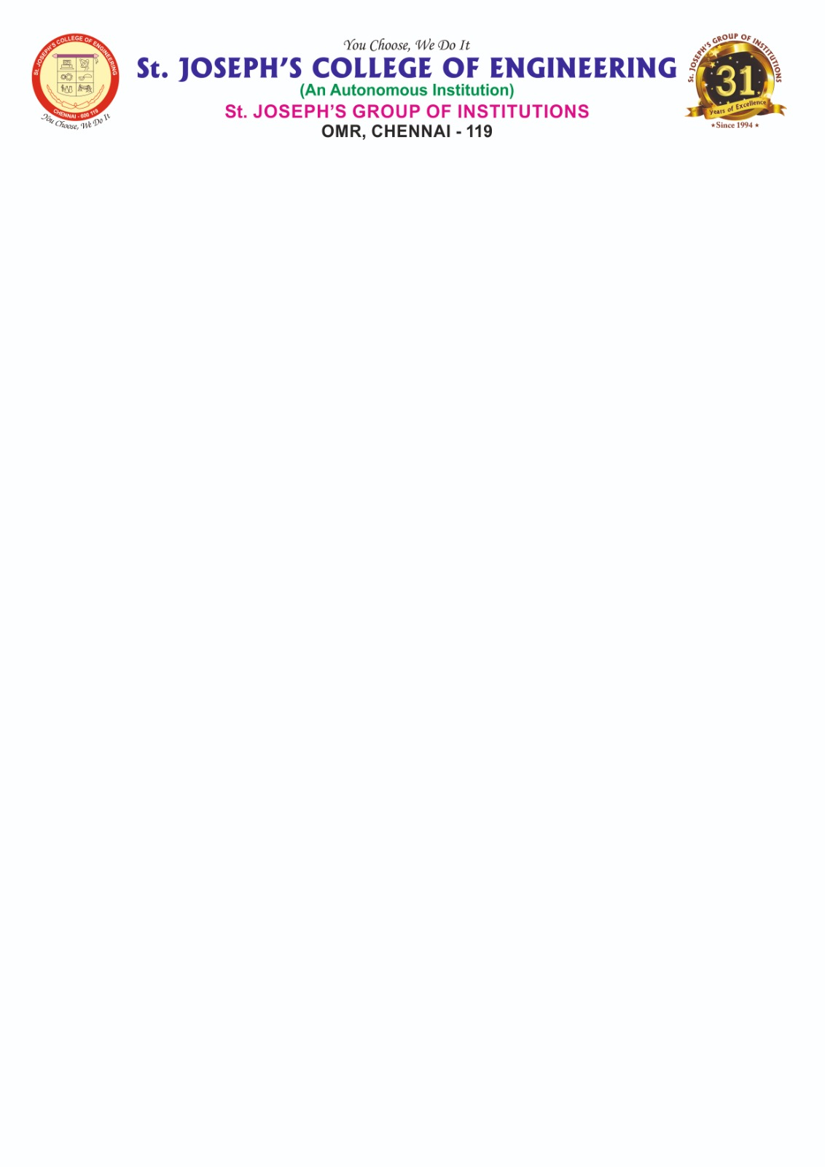

**DEPARTMENT OF INFORMATION TECHNOLOGY**

**AD1006 - Unnat Bharat Abhiyan (UBA)**

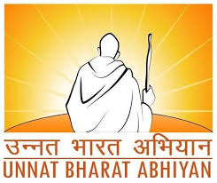

**Focusing Area:**

**SPECIAL CARE FOR PHYSICALLY CHALLENGED PEOPLE**

**Uthukadu,Kanchipuram District,Tamil Nadu**

**REPORT**

**Submitted by**

**Maria Daniel S (312321205101)**

**Ealmer DS (312321205302)**

**UBA Focusing Area Mapping with SDG and Justification**

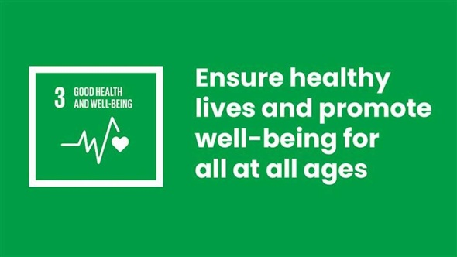

**Goal 3. Ensure Healthy lives and promote well-being for all at all ages**

Providing special care for physically challenged individuals through inclusive technologies and accessible infrastructure promotes equal opportunities and enhances quality of life. Smart assistive tools, barrier-free environments.

**3.d** Strengthen the capacity of all countries, in a particular developing countries, for early warning, risk reduction and management of national and global health risks.

**Goal 11: Make Cities and human settlements inclusive safe resilient and sustainable**

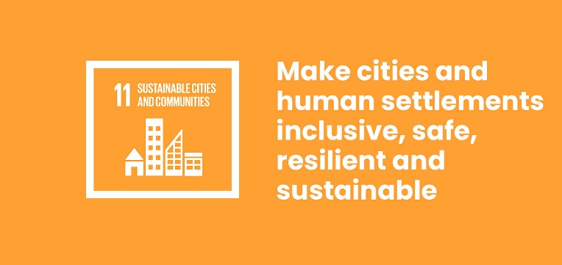

Providing special care for physically challenged individuals through inclusive urban planning and accessible infrastructure contributes to building sustainable and resilient communities. Features such as smart assistive tools, barrier-free public spaces.

**11.a** Facilitate sustainable and resilient infrastructure development in developing countries through enhanced financial ,technological and technical support to African countries, least developed countries, landlocked developing countries and small island developing states.

**INTRODUCTION**

Rural development remains one of the most critical components in India’s journey towards inclusive and sustainable growth. With the majority of the population residing in villages, addressing the needs and challenges of rural communities is vital. As part of the UBA initiative, our student team from St. Joseph’s College of Engineering adopted Uthukadu village in Kanchipuram district, Tamil Nadu. The objective was to assess the local issues and propose actionable solutions, specifically focusing on special care for physically challenged individuals. This population group is often marginalized in rural settings due to a lack of accessibility, awareness, and inclusive infrastructure. The entire project was personally carried out by our UBA student team through direct interaction with the village community. Our activities included:

* Conducting detailed house-to-house surveys to identify physically challenged individuals.
* Engaging with families and local leaders through gram sabha participation.
* Organizing an awareness camp on disability rights and government welfare schemes.
* Coordinating a free medical camp with the support of the local Primary Health Centre (PHC).

By the end of the project, several individuals had successfully enrolled in welfare schemes, received medical assistance, and gained renewed hope of inclusion in the village’s educational, health, and economic systems. Our goal now is to ensure that this momentum is sustained through community ownership and policy-level support.

**OBJECTIVES OF THE PROJECT**

The primary focus of this project under the Unnat Bharat Abhiyan was to improve the living conditions and opportunities for **physically challenged individuals** in the village of Uthukadu .Based on interactions with the villagers, surveys, and situational analysis, the following specific objectives were defined and achieved by our student team:

# Identification of Beneficiaries

To carry out a comprehensive household-level survey in Uthukadu to identify individuals with physical disabilities, document their needs, and understand their day-to-day challenges.

# Assessment of Existing Challenges

To evaluate the accessibility barriers they face in areas such as healthcare, education, employment, transportation, and participation in social life.

# Create Awareness on Rights and Government Schemes

To organize awareness campaigns and interactive sessions that inform beneficiaries and their families about available welfare schemes such as the UDID card, disability pension, and skill development programs.

# Facilitate Access to Services and Support

To coordinate with local authorities, the Primary Health Centre (PHC), and NGOs to conduct a free medical camp and assist individuals in registering for applicable schemes and receiving mobility aids.

# Propose Infrastructure Improvements

To identify key public areas like schools, anganwadis, and panchayat offices that require accessibility features such as ramps and handrails, and submit proposals for their construction.

# Promote Inclusive Skill Development

To recommend vocational training programs tailored for differently-abled individuals, enabling them to gain employment or start self-sustained businesses.

# Foster Long-Term Community Engagement

To initiate the formation of a local volunteer network that will continue to support the physically challenged beyond the duration of this project.

Through these objectives, our team aimed to not only highlight the needs of a neglected section of society but also contribute practically toward a more inclusive and equitable rural ecosystem. These goals guided every step of our intervention in the village and were aligned with the vision and mission of the Unnat Bharat Abhiyan.

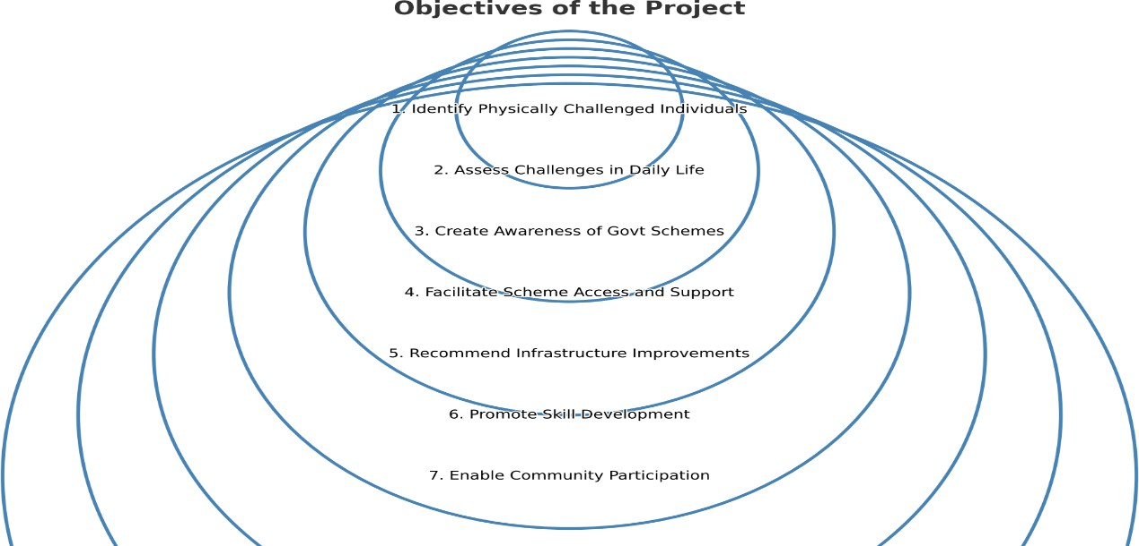

**VILLAGE PROFILE – Uthukadu**

**Uthukadu** is a moderately populated rural village situated in the Kanchipuram Taluk of Kancheepuram district, Tamil Nadu. The village is located approximately 10 kilometers east of the Kanchipuram District Headquarters and 65 kilometers from Chennai, the state capital. It falls under the postal code 631604 and is surrounded by Kanchipuram Block to the west, Sriperumbudur Block to the east, Uttiramerur Block to the south, and Vembakkam Block to the south-west.

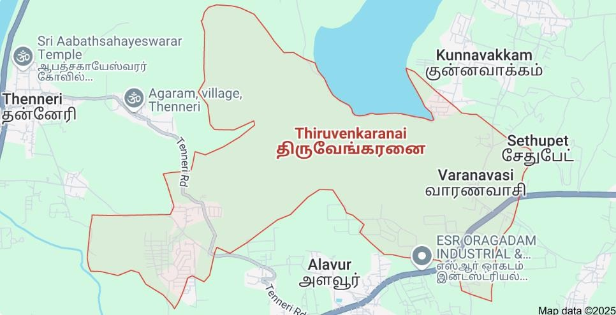

According to the baseline survey conducted by our team in association with data from the UBA household study, the total geographical area of the village is 615 hectares. The village has a population of 1,668 individuals, comprising 831 males and 837 females. There are 432 households in total, with an average family size of approximately 3.8 members. Tamil is the primary language spoken in the village, although some youth are also able to communicate in English.

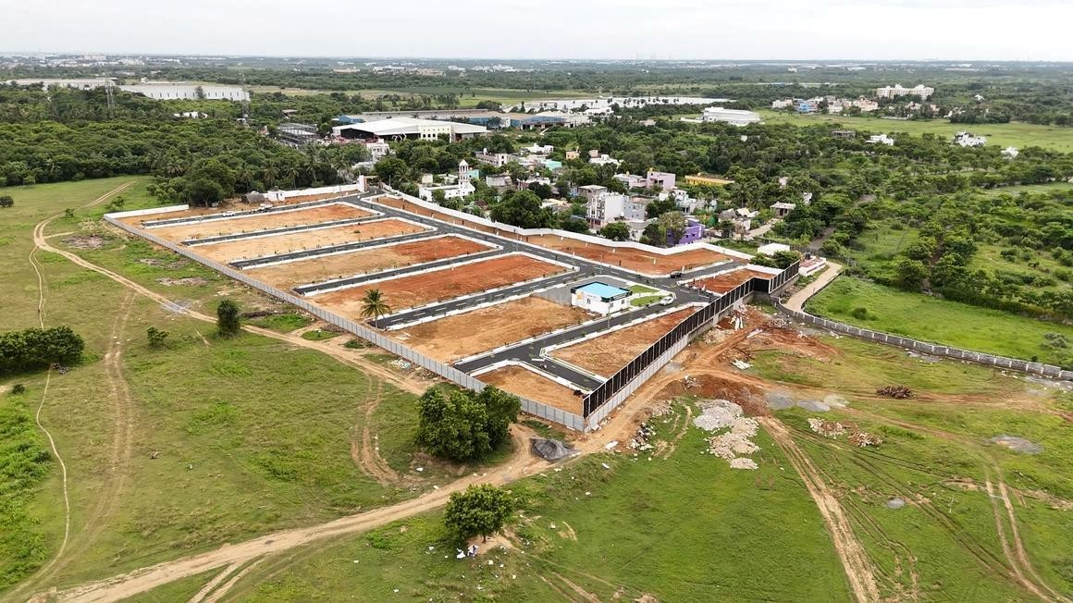

In terms of literacy, the overall rate stands at 64.04%. Male literacy is recorded at 72.96%, while female literacy is relatively lower at 55.23%. This gender gap reflects a broader need for educational inclusivity, especially for women and girls in rural areas.

The primary occupation inUthukadu is agriculture. Most residents are engaged as landowners or seasonal agricultural laborers. During non-agricultural seasons, many villagers rely on unskilled employment opportunities under government programs such as the Mahatma Gandhi National Rural Employment Guarantee Act (MGNREGA), which provides 100 days of wage employment to rural households.

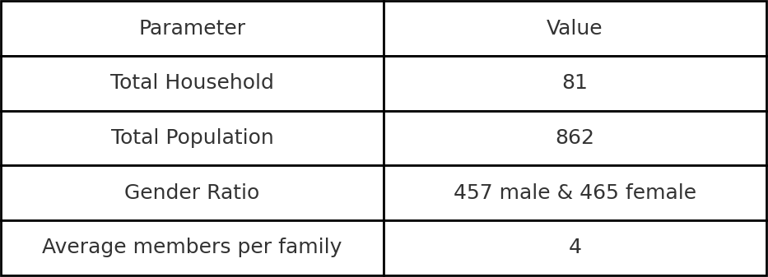

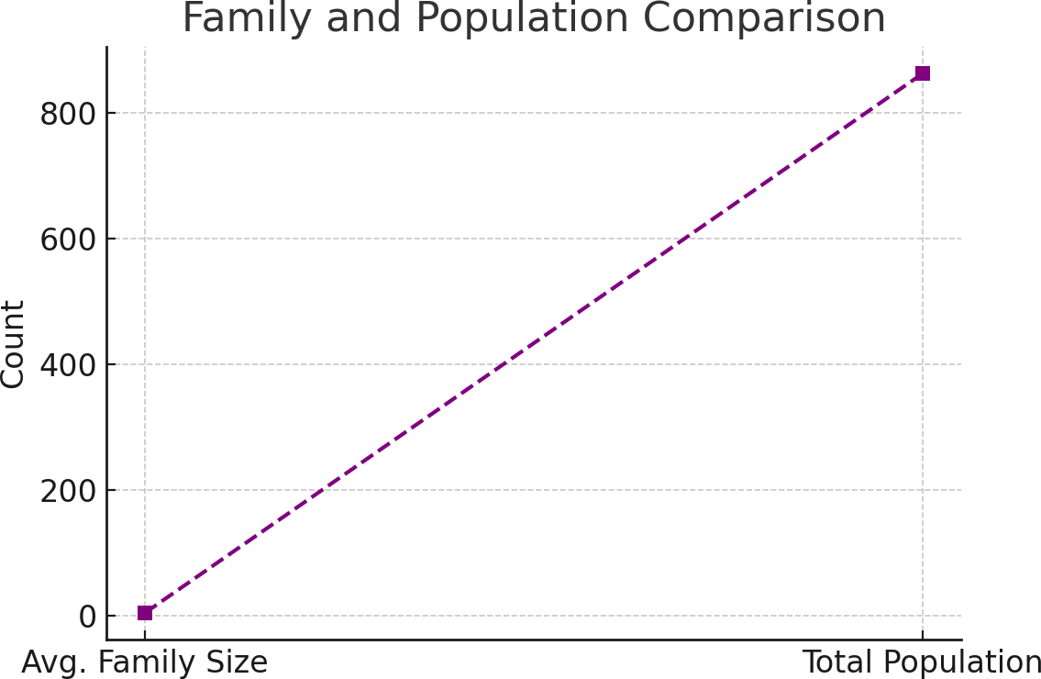

The village has essential amenities like a primary school, anganwadi center, PDS shop, and a nearby PHC, though it lacks disability-specific services. Transport to nearby towns is available but not accessible for the physically challenged. Our survey revealed key gaps: absence of ramps in public buildings, limited mobility aids, poor awareness of government schemes, and no vocational training for differently-abled individuals.

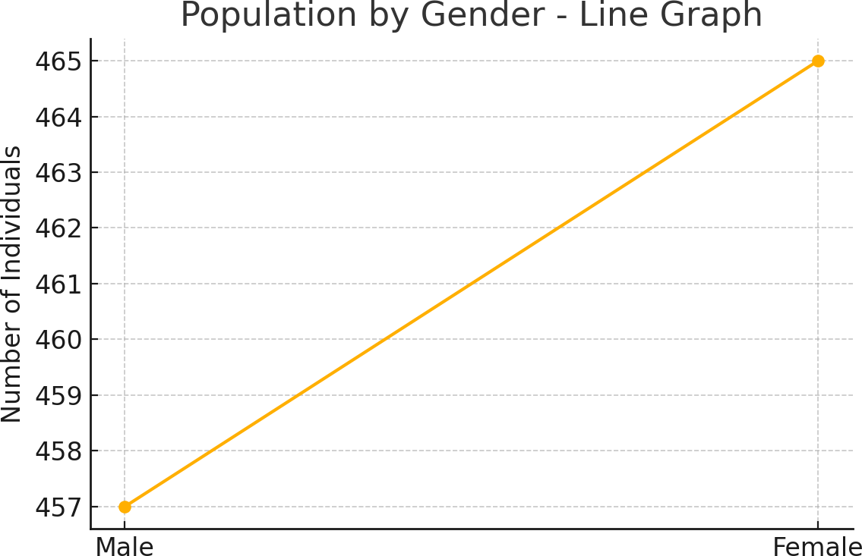

**BASELINE SURVEY AND IDENTIFICATION OF PHYSICALLY CHALLENGED INDIVIDUALS:**

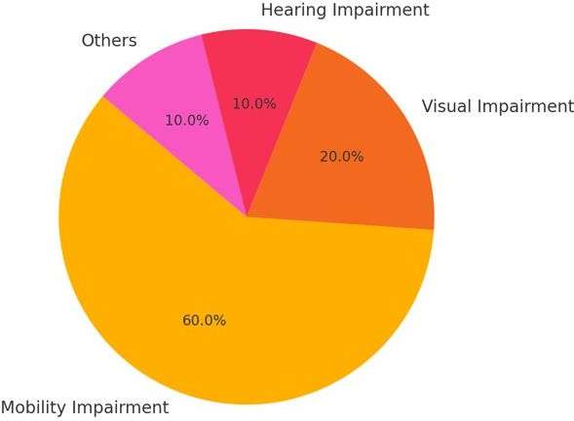

*Figure 1: Distribution of Disability Types Among Affected Individuals (Sample- based Data)*

To gain a thorough understanding of the condition of physically challenged individuals in Thiruvenkaranai, our UBA student team conducted a detailed door- to-door baseline household survey. The primary objective of this survey was to identify the number of differently-abled individuals in the village, understand the nature of their disabilities, evaluate their current living conditions, and assess their access to government support schemes. Covering all 432 households, the survey ensured that every segment of the population was represented and that the data collected was both inclusive and accurate.

In total, 1,668 individuals were surveyed, out of which 28 were identified as physically challenged—representing approximately 1.7% of the village’s total population. The breakdown of disabilities revealed that 60% suffered from mobility impairments, 20% had visual impairments, 10% had hearing difficulties,

and the remaining 10% were affected by other issues such as speech or neurological disorders. This data helped our team classify the support required and understand the priority needs within this population group.

# Observations

A number of critical observations emerged from the survey. Many individuals suffering from mobility issues did not possess even the most basic assistive tools such as wheelchairs, walking sticks, or crutches. This lack of support severely restricted their movement and independence. Additionally, we observed that key public infrastructure—such as the village school, anganwadi centers, and Panchayat buildings—lacked accessibility features like ramps or handrails, further isolating physically challenged individuals from social and civic engagement.

The impact on education was significant. Several individuals, particularly children and youth, had dropped out of school because the buildings were not accessible or because they lacked social support systems like peer inclusion or transport facilities. Furthermore, our team discovered that more than half of the differently-abled persons surveyed were unaware of the existence of government schemes designed specifically to support them, such as the UDID card or disability pensions.

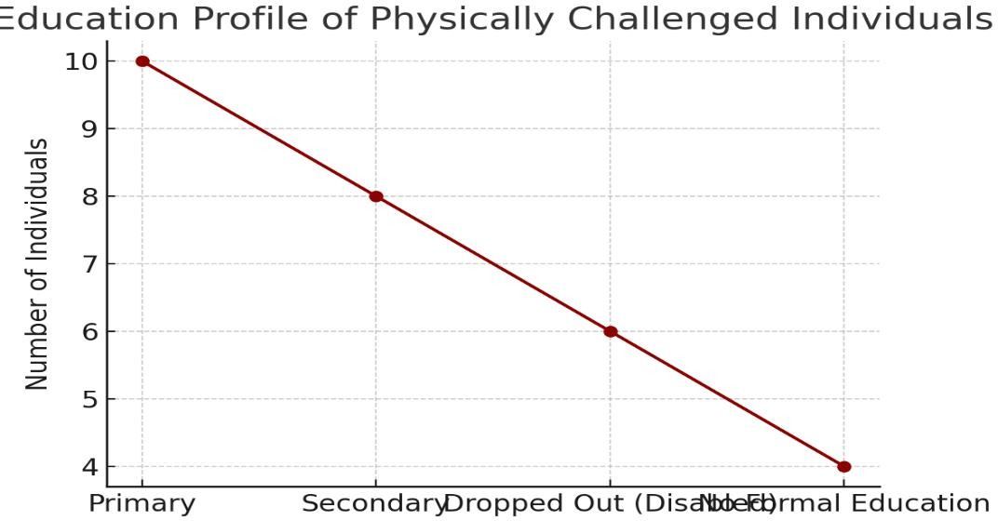

**CHALLENGES FACED BY PHYSICALLY CHALLENGED INDIVIDUALS:**

During our extensive interaction and household survey in Thiruvenkaranai, we uncovered several challenges faced by physically challenged individuals. These issues affect not only their day-to-day activities but also their long-term well- being, dignity, and participation in the community.

One of the most glaring issues is the **lack of physical infrastructure**. The village does not have ramps or handrails in any of its public institutions such as schools, anganwadis, or Panchayat offices. Roads are narrow and uneven, making mobility extremely difficult for those with disabilities, especially wheelchair users. Public and household toilets are not designed with accessible features, further compounding the challenge.

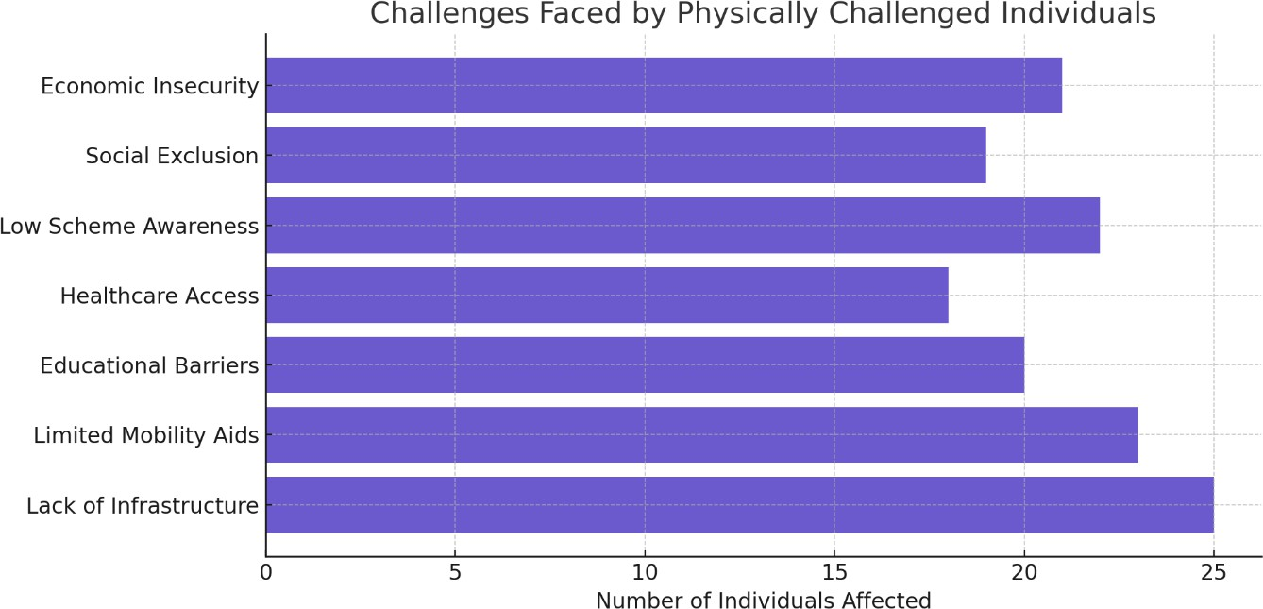

**Access to mobility aids** is another pressing concern. Out of the 28 physically challenged individuals identified, only a handful had access to wheelchairs or walking sticks. Most families cited cost and unawareness about government

provision of free aids as major reasons. As a result, many individuals are homebound and dependent on family members for basic mobility.

**Educational challenges** are equally significant. Physically challenged students are often forced to drop out due to a lack of support in schools, such as ramps, special educators, or transport facilities.

A major issue we observed was the **lack of awareness about government schemes**. Most individuals were unaware of the UDID card, disability pension, and assistive device distribution schemes.

Lastly, **economic exclusion** remains a critical challenge. None of the individuals surveyed were employed, nor did they have access to skill-building or livelihood opportunities. Their families often face additional financial strain, as caregivers are forced to stay home, thereby reducing household income potential.

These challenges are deeply interconnected and require a holistic and sustained approach to resolution. They served as the foundational motivation for our awareness drives, medical camps, and proposal submissions during the course of this project.

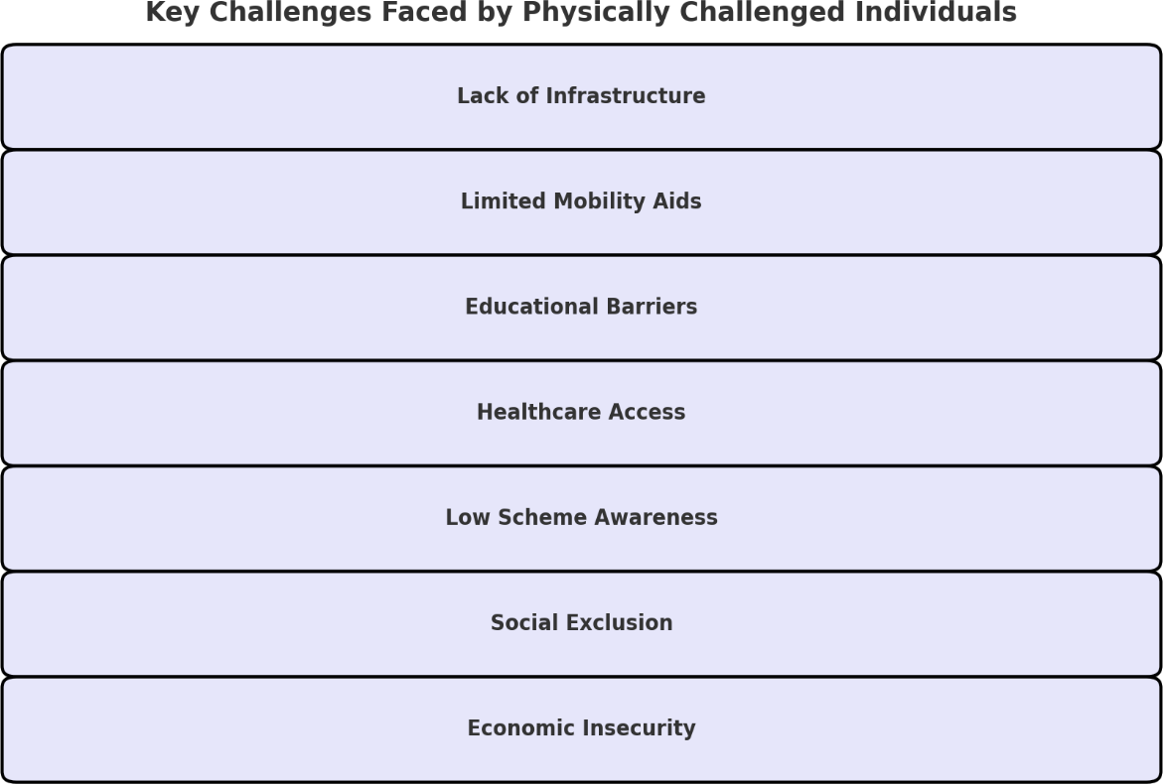

**GOVERNMENT SCHEMES AVAILABLE FOR PHYSICALLY CHALLENGED INDIVIDUALS**

As part of our project in Thiruvenkaranai, one of the key components was creating awareness about government schemes that are specifically designed to support the physically challenged population. During the household survey, we found that awareness and enrollment in such schemes were extremely low. To address this gap, we collected information from official Tamil Nadu and central government sources and presented it to the villagers in simplified terms through posters, handouts, and personal counseling.

The following are some of the major government schemes available to physically challenged individuals that were introduced to the community:

# UDID – Unique Disability ID Card

The Unique Disability ID (UDID) project by the Department of Empowerment of Persons with Disabilities aims to issue a digital disability certificate and ID card to each person with a disability. It streamlines the process of accessing various government benefits and ensures national-level recognition.

* + **Eligibility:** Persons with 40% or more disability
  + **Benefits:** Single digital document for availing benefits, easy access to pensions, concessions, and reservations

# State Disability Pension Scheme

Under the Tamil Nadu Social Welfare Department, individuals with a disability are entitled to a monthly pension.

* + **Eligibility:** Minimum 40% disability; income limit applies
  + **Benefit:** ₹1,000 per month credited directly to the bank account
  + **Documents Required:** Disability certificate, Aadhaar, bank passbook, and ration card

# Assistance to Disabled Persons for Purchase/Fitting of Aids and Appliances (ADIP Scheme)

Implemented by the Ministry of Social Justice and Empowerment, this scheme provides assistive devices such as wheelchairs, tricycles, crutches, and hearing aids to eligible beneficiaries.

* + **Eligibility:** Indian citizen with 40% disability and income below ₹22,500 per month
  + **Benefit:** Free or subsidized aids provided through special camps
  + **Mode of Delivery:** Organized by NGOs and District Social Welfare Offices

# Scholarship for Students with Disabilities

The Department of Empowerment of Persons with Disabilities offers scholarships to students from Class 9 to Post-Graduate level.

* + **Eligibility:** 40% disability, valid UDID card, and income below ₹2.5 lakh per annum
  + **Benefit:** Monthly financial assistance, books, and transport allowances

# Accessible India Campaign (Sugamya Bharat Abhiyan)

This national initiative focuses on making public buildings and transportation accessible.

* + **Target Areas:** Government buildings, schools, transport systems
  + **Scope for Village:** Ramp installation in Panchayat buildings, PHCs, and schools

We conducted an **Awareness Camp** where these schemes were explained to the villagers in Tamil using real-life examples. Application support was provided to families on the spot. As a result, 14 individuals initiated the UDID card application process, and 8 families submitted documents for the disability pension scheme.

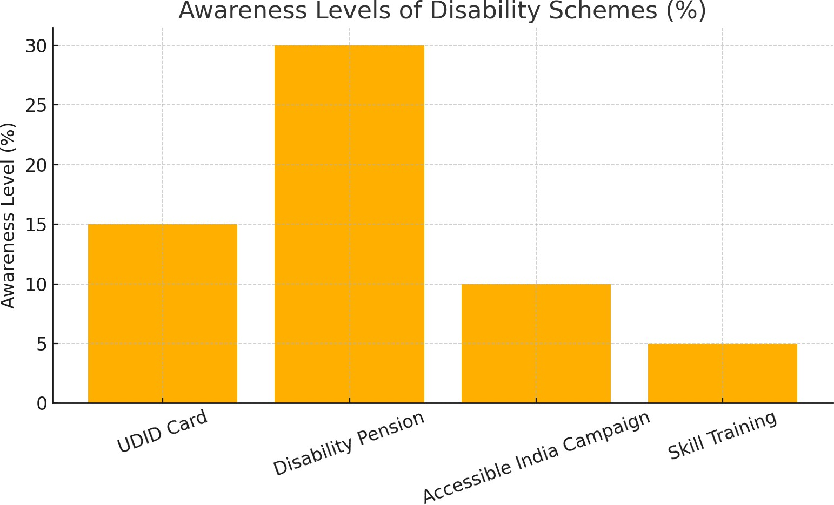The goal of this intervention was not only to inform but also to **empower the villagers** to claim their rightful benefits and become more integrated into the development framework. These schemes, if utilized correctly, can significantly uplift the lives of differently-abled individuals and their families.

**ACTIVITES**

As part of our Unnat Bharat Abhiyan (UBA) project, my partner and I visited Thiruvenkaranai village and conducted a range of activities over few days. Each activity was carefully planned and executed with the goal of supporting physically challenged individuals in the village and raising awareness among the local community. Our presence in the village allowed us to interact directly with residents, understand their challenges, and respond in a meaningful and impactful manner.

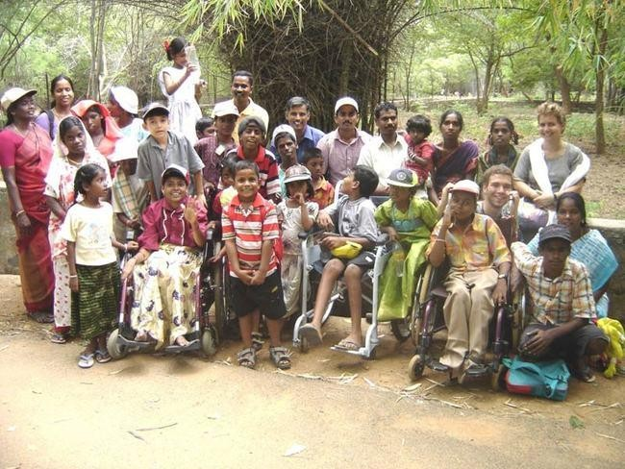

Our first major activity was conducting a **door-to-door household survey**. We personally visited all 432 households in the village, introducing ourselves as student volunteers and explaining the purpose of the survey. Using printed forms and direct interviews in Tamil, we identified physically challenged individuals, noted their needs, and documented their access (or lack thereof) to government

support schemes. This activity helped us build trust with the community and gather accurate ground-level data.

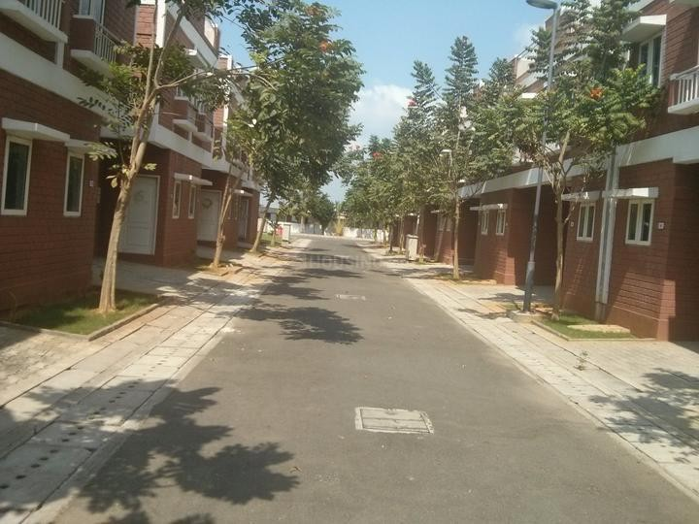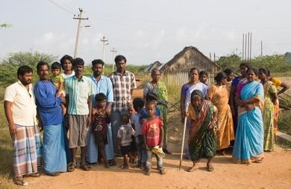

Following the survey, we organized a **community awareness session** in collaboration with the village Panchayat. The session was held in the community hall, where we used posters, charts, and real-life examples to explain government schemes such as the UDID card, disability pension, and assistive devices available under the ADIP scheme. Many villagers actively participated, asked questions, and showed genuine interest in applying for these benefits.

We also conducted a **basic medical screening camp** with the help of the local Primary Health Centre (PHC). We coordinated with the PHC nurse to assess the needs of the physically challenged and provided assistance in scheduling follow- ups for further disability certification and UDID registration. This camp helped bring health services closer to the people who had limited mobility and access.

Another key activity was **resource support and application assistance**. We sat with interested families and helped them fill out forms for disability pension and UDID registration. For those without digital literacy, we explained the process, collected the necessary documents, and facilitated the submission through online portals. We also spoke with Panchayat officials to encourage their support in verifying documents and endorsing local applications.

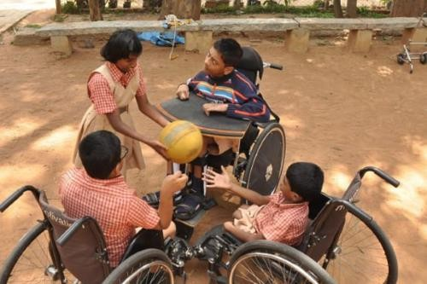

Additionally, we carried out a **physical audit of public spaces** such as the primary school, PHC, anganwadi, and the Panchayat office. We took photographs and notes highlighting the lack of ramps, handrails, and accessible toilets. This documentation was submitted along with our recommendations for infrastructural improvement.

Throughout our visit, we made a point to engage villagers in informal conversations. These interactions were not only valuable for gathering unspoken insights but also served to strengthen community bonds. Several families expressed gratitude and relief that someone had finally taken an interest in their needs.

In summary, every activity we conducted was hands-on and field-based. From identifying issues to proposing solutions, we took ownership of every step in the process. The experience was deeply humbling and taught us the real meaning of inclusive development. Our goal is now to ensure that these activities continue through local stakeholders and that the impact we made serves as a foundation for long-term change.

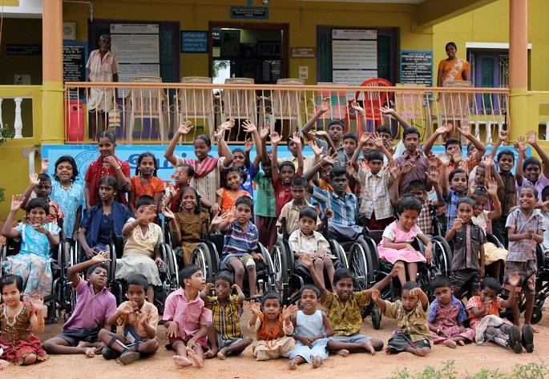

**CONCLUSION**

Our journey as part of the Unnat Bharat Abhiyan (UBA) project in Uthukadu was a transformative experience, both for us as student volunteers and for the community we engaged with.

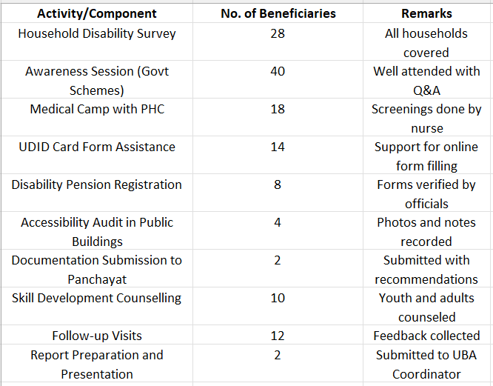

Through our household surveys, awareness sessions, health screenings, and support with government schemes, we gained meaningful insights into the challenges faced by differently-abled individuals. We uncovered stories of resilience and brought attention to long-overlooked needs.

Our efforts went beyond data collection—we empowered families with information, helped initiate applications for disability benefits, and promoted

inclusive development. The project reinforced our belief that real progress begins with equal access and dignity for all.

We believe this work has laid the groundwork for lasting impact. With continued support from the Panchayat, NGOs, and future UBA teams, Thiruvenkaranai can truly become a model of inclusive rural development.

We are thankful for the opportunity to serve and contribute to the vision of Unnat Bharat Abhiyan: empowering villages through collective and compassionate action.

**“Our Journey in Uthukadu”**

***(Survey → Awareness → Health Camp → Application Assistance)***

